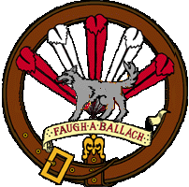
New Member Information

Welcome to Clann Tartan! This is a brief orientation for new members on how we are organized, our events, and what you need to get started. Clann Tartan is a non-profit, tax-exempt corporation under the laws of Minnesota. We operate in a democratic fashion according to bylaws that are published in the Clann Manual.

There are two sides to the organization of Clann Tartan, the Corporate side and the Regimental side. Each side of the Organization has an elected body that oversees the various aspects of operation for Clann Tartan.

Corporate: The elected Board of Directors oversees The Corporate business. The Board meets monthly to review the business aspects of keeping Clann Tartan running, from appearance contracts to the financial status. They also oversee the quarterly corporate meetings for the membership. At these meetings Members may discuss and/or vote on subjects to be decided upon by the group as a whole. The Bylaws can only be changed at the Annual Meeting in February, and General Regulations can be changed at the Quarterly Meetings. The Board of Directors is elected to a two-year term.

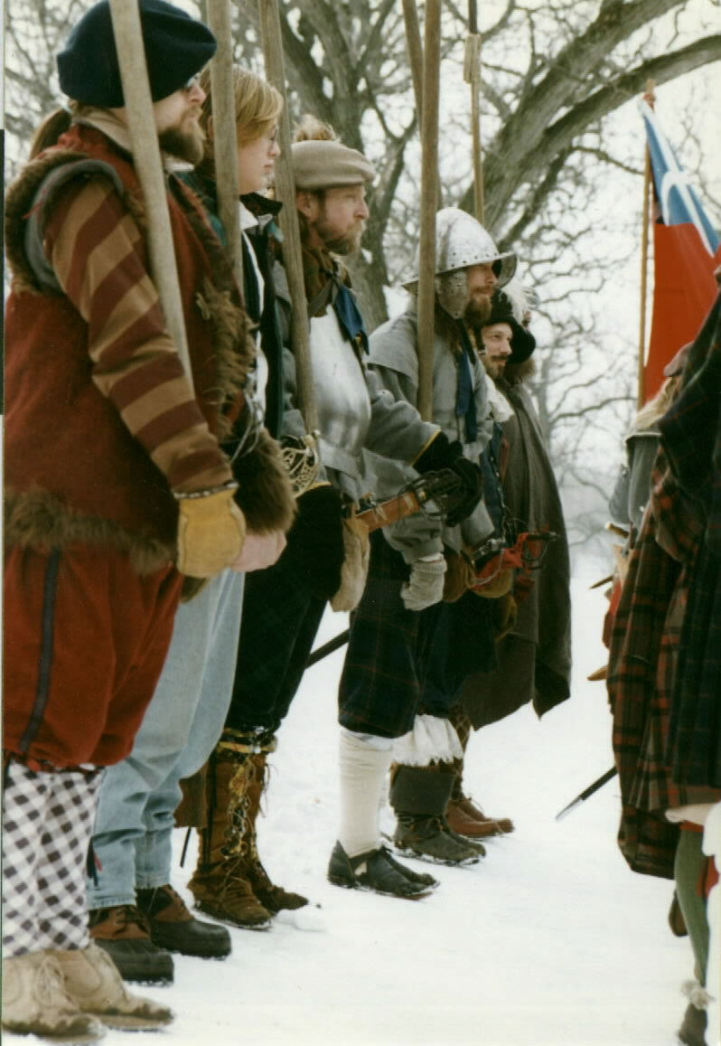
Regimental: The Regimental staff is elected each November and represents our camp and company, overseeing the “performance” aspects of Clann Tartan. The Staff makes sure our equipment is maintained and acts as our “site director” when making appearances. The Staff holds meetings as needed.

Many of the times that Clann Tartan members gather it is to support some aspect of the Corporate or Regimental structure, but we also have many social gatherings. From the monthly Night at the Pub to our annual Progressive Dinner after First Footing, our members enjoy getting together to enjoy each other’s company.

To help meet the on-going needs of Clann Tartan and the interests of the members, there are also various committees and guilds. These groups help fill the gaps between the social and Corporate/Regimental aspects of Clann Tartan.
Committees are made up of members who volunteer to help with some of the “behind the scene” items. Committees will be formed for specialized tasks, such as planning for a special event. There are also permanent Committees that handle items such as the Newsletter and our Website.

Guilds are groups of members who get together for the purpose of teaching and learning about skills used in interpreting Scottish history to the public at our appearances. The gatherings are often social in nature, but help support the ongoing education of our members. These Guilds cover areas such as Dance, Music, Military Drills, and others. Members are encouraged to start other Guilds to help educate each other.

Membership Requirements
There are two levels of membership in Clann Tartan, Associate and Active. Associate members are welcome to participate in non-regimental activities such as Dance, Music and other social events.

If you would like to participate in our shows and appearances, including voting for Staff and Board members. you can become an Active member. There are a few additional requirements to start you on the road to Active Membership; here is a quick summary of them;:

First, subscribe to the Newsletter. This you’ve already done by submitting your membership dues.

Second: have appropriate historical attire. This doesn’t have to happen all at once. Most of the clothing items are very easy and economical to make, and many members have items you can borrow to get you started.

The third main thing to get started is the ability and willingness to accurately portray a member of a Scottish military organization. (Campfollowers are considered part of our military organization, and Sutlers would have needed the approval of the Regiment to set up shop within the camp.)

Members continue to build upon these three items by completing various Muster Requirements. There are minimum requirements for all members, even if they don’t plan on pursuing these areas in depth. All basic requirements apply to everyone; women should have a basic knowledge of our military drills and men should know how to spin wool with a drop spindle.

These are not “tests” as much as a chance to learn an activity or provide hands-on experience with the things we do. All items are geared towards giving each member a standard base of knowledge when interacting with the public and allow Clann Tartan to maintain a minimum standard of historical accuracy at our appearances. We do make allowances for those who may not physically be able to do certain activities.

Beyond the basic areas of Muster, members may continue to learn more activities, both inside and outside the scope of Clann Tartan Muster Requirements until they reach the highest level of Muster, Gaffney’s Own, where they must demonstrate a level of expertise in an area of their choosing.

Regimental History
The “story” that we portray.
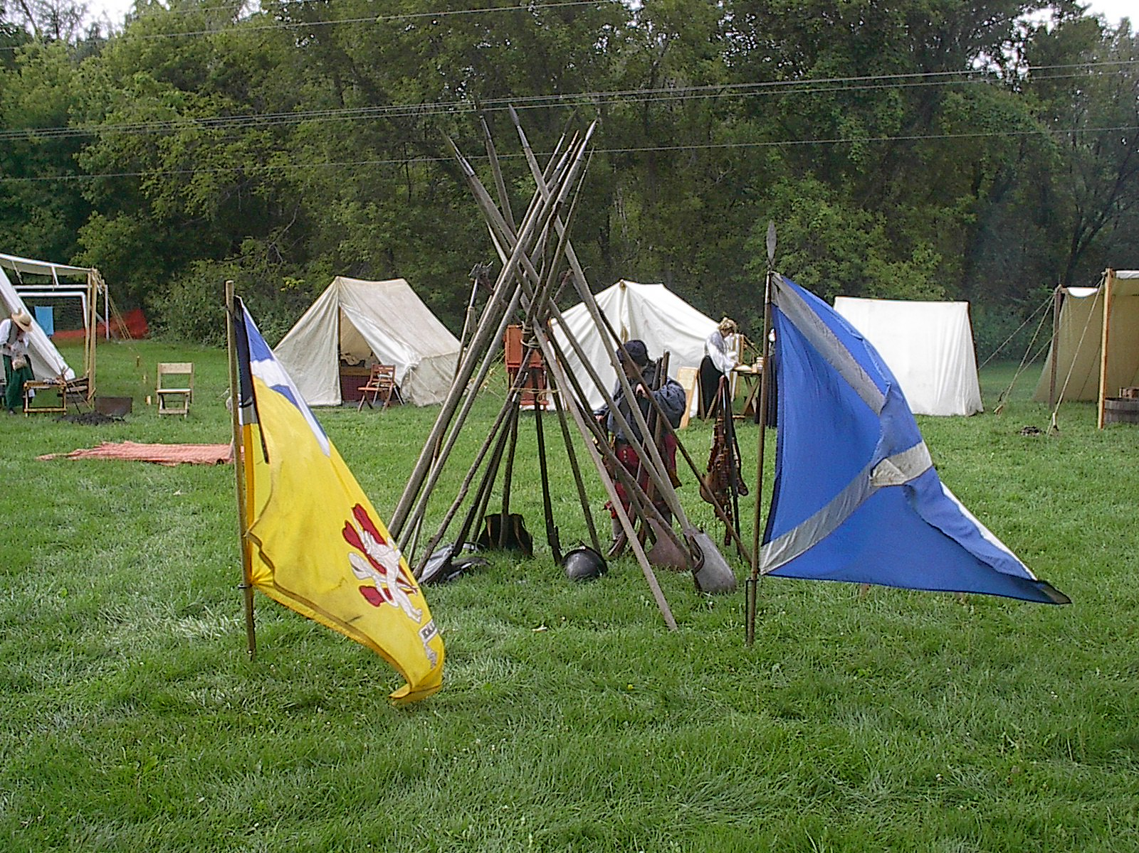
When appearing in front of the public, our camp is currently in Scotland and the year is 1630. The “Warres in the Germanies” (30 Years War) have been going on since 1618. The army of Gustavus Adolphus has just landed in Pomerania (northern Germany/Poland) with 30,000 men and is waiting for re-enforcements before advancing south. Colonel Gaffney has been granted a commission to raise a regiment of mercenaries who will soon travel to the continent to join the army of Sweden. As soon as enough men have been recruited we will march to the coast and ship out from Cromarty, Scotland.

Crops in some areas of Scotland have been poor recently, so some recruits are seeking employment because of to the lack of food. Others are joining to help support the Protestant cause against the Catholic armies, or to help Elizabeth Steward, the daughter of our late King James VI. Elizabeth married the King of Bohemia, where Protestants threw some Catholic governors out of a third story window in Prague and started the war.

Some of our officers and soldiers are veterans of continental service, having served in the early portion of the war with Christian IV, of Denmark, or with Gustavus, helping to solidify Sweden’s trading interests around the Baltic Sea. The Sutlers, or craftspeople in the camp are local people who have come to sell supplies to this new military unit, or they may have contracted to follow the regiment and provide their services.

Attending Events
The calendar of events and meeting schedule is published in our monthly newsletter, as well as on our website at www.clanntartan.org/events. We try to provide directions to events and other vital data as well; however, often the event organizers do not provide that information in time for publication. If you ever have any questions, be sure to contact a Staff member.

If you would like to attend an event, you must contact a member of the Regimental Staff at least seven days prior to the event, and sooner if possible. This is very important for the following reasons:
- Clann Tartan provides meals for its members at most events. The Staff needs to know how much food to buy. You are welcome to make your own meal arrangements, but we have a lot of great cooks!
- If you do not yet have a tent, Staff members can help find space for you either by borrowing a corporately owned tent or possibly “bunking” with another member who has extra space.
- Often, Clann Tartan is asked by event coordinators to provide schedules of demonstrations we may be doing. It’s nice to know how many people we will have in attendance and what demonstrations they may be willing to participate in.

When attending “out of town” events, you may be eligible for reimbursement for mileage and/or gas expenses. Reimbursement requests must be made within 30 days after the event. Contact a Staff member or the Treasurer for specific eligibility requirements.

If you need help getting together clothing, eating utensils or just need to know what else you might need to bring to get you through a show, contact one of your Staff members. We have various resources that will help you get started, as well as lists of people and places to borrow or buy from.

If you want to attend one of the “Guild” Meetings, there is no need to call ahead, just get in touch with a Staff member or someone from that Guild, or check your newsletter and find out when and where to show up!

And remember, if you ever have any questions, just contact a Board or Staff member, we are here to help you get started in what we hope to become an enjoyable new experience for you

